Coursework Cover Sheet

Students should complete the input fields contained in this form and attach it in front of your formal assessment submission. All fields within this form are required. Please ensure that check boxes and radio buttons are appropriately selected. The last three questions are just for you to personally consider.

# Department and assessment information:

**School Name: School of Science**

**Assessment title:** Test-Driven Development of a Smart Building Controller Class

**Course Title:** BSc (Hons) Computing

**Module Title:** Software Development

**Module Code:** C02401

**Year of Study:** 2023

# Academic Misconduct / Plagiarism Declaration

By attaching this front cover sheet to my assessment I confirm and declare that **I am the sole author of this work**, except where otherwise acknowledged by appropriate referencing and citation, and that I have taken all reasonable skill and care to ensure that no other person has been able, or allowed, to copy this work in either paper or electronic form, and that prior to submission I have read, understood and followed the University regulations as outlined in the [Academic Integrity Policy and Procedure for Academic Misconduct](https://www.uclan.ac.uk/assets/student-contracts/2023-24/academic-integrity-policy-2324.pdf)

# Have you checked the following? This will help your assessment achievement.

I have applied the learning outcomes for this module

I have checked for Academic Integrity via Turn-it-in

I have followed the guidance in the Assessment Brief and have not used AI to boost my grade unfairly.

I have used references in accordance with instructions in the Assessment Brief

I have proofread my work for spelling, grammar and punctuation.

I have checked that the word count/size of this submissions accords with the guidance provided in the Assessment Brief.

# Well-being

We wish to support any student who is experiencing mitigating circumstances which prevents students from performing to the best of their ability when completing or submitting assignments. If you are experiencing such circumstances, then you may apply for Mitigating Circumstances**.** Wherever possible this must be done prior to handing in your assignment.

Do you need to apply for mitigating circumstances for this assignment No

Please refer to the [Mitigating Circumstances Policy](https://msuclanac.sharepoint.com/sites/CyprusStudentHub/SitePages/Mitigating-Circumstances.aspx)

# Questions you may wish to consider:

1. Have I allowed sufficient time to prepare this assessment? ___YES_____
2. Have I reflected on previous feedback and made improvements in accordance with advice? ____YES____
3. What grade am I expecting? ____100____

**Test-Driven Development (TDD) of a Smart Building Controller Class**

Table of Contents

Department and assessment information: 1

Academic Misconduct / Plagiarism Declaration 1

Have you checked the following? This will help your assessment achievement. 1

Well-being 2

Questions you may wish to consider: 2

1. Overview of TDD 4

2. L1R1- First iteration of the RED-GREEN-REFACTOR cycle 5

2.1 RED state 5

2.1 GREEN state 5

2.1 REFACTOR state 5

3. L2R3 – Level 2 RED-GREEN-REFACTOR cycle 6

3.1 RED state 6

3.2 GREEN state 6

3.3 REFACTOR state 6

4. L3Rx- Level 3 RED-GREEN-REFACTOR cycle 7

4.1 RED state 7

4.2 GREEN state 7

4.3 REFACTOR state 7

5. L4Rx- Level 4 RED-GREEN-REFACTOR cycle 8

5.1 RED state 8

5.2 GREEN state 8

5.3 REFACTOR state 8

6. STD – Valid States and Valid Transitions 9

7. Stubs and Mocks 9

8. Lessons Learned and Conclusion 9

References 9

# Overview of TDD

The strategy to develop the BuildingController class was to first analyse the supposed structure of the project, in other words, where the system will be operating, what is its primary purpose, desired functionality and security considerations. Additionally, the functional requirements were analysed. After the initial analysis, the main class and its dependencies were outlines, i.e. all the members, all the methods and their signatures were coded, so that when developing the initial tests there would not be a necessity to create tests for existence/non-existence of these methods. Following that a standard test-driven development was used: first, develop the test for the future implementation, and then implement the actual code itself. In this development the red-green-refactor cycle was as follows: complete all of the tests and functionality and be in the green state and after that – refactor. This approach presents several benefits: ensures that test will definitely be written since making them after the developments usually seems redundant; forces the developer to think ahead and form the intended behaviour of code rather than the code itself; provides motivation for completing steps after steps - especially when the tests are small and fast to make (Larman, 2004). The challenges, however, are fairly obvious – this style of coding is unfamiliar and thus the process is much slower; there must be approximately twice as much code written, if not more; lastly, bugs can also be introduced in tests themselves. In relation to the Smart Building project specifically, one of the most prominent challenges was to make small tests, thus eradicating possible errors in them. This was especially due to the fact that most of the functionality of the class is clumped within one of the methods (‘SetCurrentState’). To combat this, the code inside the method was split into several blocks each for a separate case of its usage (for ‘fire alarm’, ‘fire drill’ and the rest). This allowed to comment out and test separate blocks of code.

Literature lists several skills related to TDD that increase employability: extended discipline in coding standards, better software design and ability do produce maintainable code (Janzen, 2005). One could argue that any job title which is related to programming can benefit from test-driven development and skills that it requires. However, there are more suitable roles that practically require TDD, for example, Test Automation engineer, QA engineer, DevOps, software architect, release manager and so on (Rajani, 2017).

|  |  |  |
| --- | --- | --- |
| Level | Number of Tests | Number of Test Cases |
| Level 1 | 4 | 6 |
| Level 2 |  |  |
| Level 3 |  |  |
| Level 4 |  |  |
| Totals: |  |  |

# L1R1- First iteration of the RED-GREEN-REFACTOR cycle

## 2.1 RED state

The test for this requirement has to be combined with the second requirement (L1R2). This is because the constructor in R1, sets the buildingID, but there is no way to test if the constructor has worked correctly, since the building ID is private and there is no getter method yet. Combining it with the second requirement allows to call the constructor and then check that it set the id correctly with a GetBuildingID method. For this test only the requirements were consulted with (appendix B).

[Test]

//L1R1_L1R2

public void L1R1_L1R2_Constructor_SetBuildingID()

{

//Arrange

string newBuildingID = "test";

var controller = new BuildingController(newBuildingID);

//Act

string returnedBuildingID = controller.GetBuildingID();

//Assert

Assert.AreEqual(newBuildingID, returnedBuildingID);

}

The test is failing because there is no constructor, or a getter method in the class.

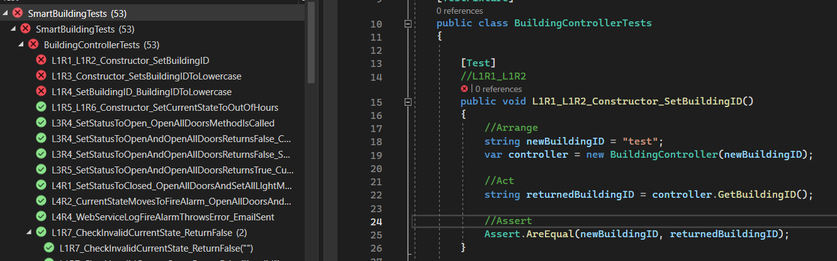

## 

## 2.1 GREEN state

To go to the green state, the necessary code was added to the class.

Before:

**public BuildingController(string buildingID)**

**{**

**}**

**public string GetBuildingID()**

**{**

**return "";**

**}**

After:

**public BuildingController(string buildingID)**

**{**

**this.buildingID = buildingID.ToLower();**

**this.currentState = "out of hours";**

**}**

**public string GetBuildingID()**

**{**

**return buildingID;**

**}**

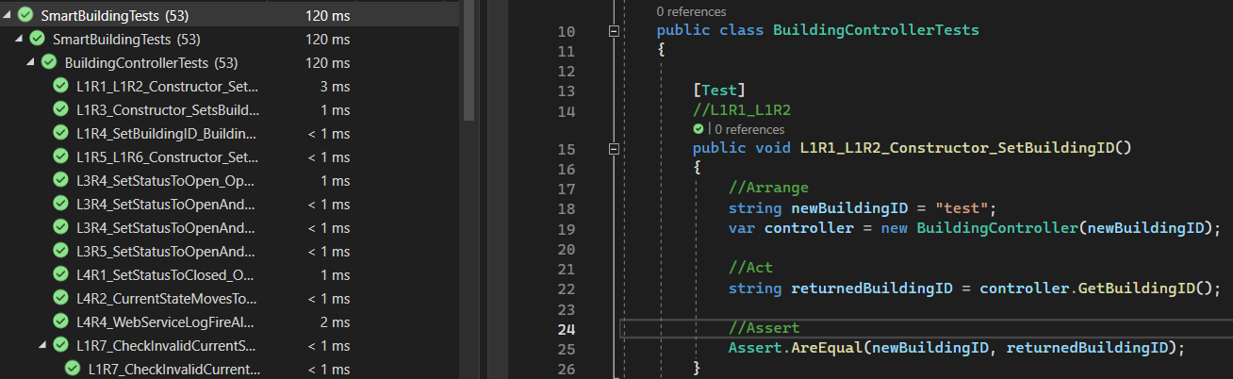

## 2.1 REFACTOR state

During refactor state nothing was done. This is due to the fact that there is nothing to be done.

# L2R3 – Level 2 RED-GREEN-REFACTOR cycle

## 3.1 RED state

To test this requirement, it was broken into two parts:

The first is when the constructor sets the state to lowercase when initializing and, second part, when it throws an exception when it is a wrong state. Only the requirements were consulted for this.

First test:

**[TestCase("out of hoUrs")]**

**[TestCase("clOsed")]**

**[TestCase("opeN")]**

**//L2R3**

**public void L2R3_SetCurrentStateToUpperCase_SetsToLowerCase(string testState)**

**{**

**//Arrange**

**var controller = new BuildingController(buildingID: "testID", startState: testState);**

**//Act**

**string setState = controller.GetCurrentState();**

**//Assert**

**Assert.AreEqual(testState.ToLower(), setState);**

**}**

Second test:

**[TestCase("fire drill")]**

**[TestCase("fire alarm")]**

**//L2R3**

**public void L2R3_SetCurrentStateToWrongState_ThrowException(string testState)**

**{**

**string correctMessage = "Argument Exception: BuildingController can only be initialised to the following states 'open', 'closed', 'out of hours'";**

**//Arrange & Act & Assert**

**Assert.Throws(Is.TypeOf<ArgumentException>()**

**.And.Message.EqualTo(correctMessage),**

**() => new BuildingController(buildingID: "testID", startState: testState)**

**);**

**}**

This is in the red state because there is yet no functionality for these tests.

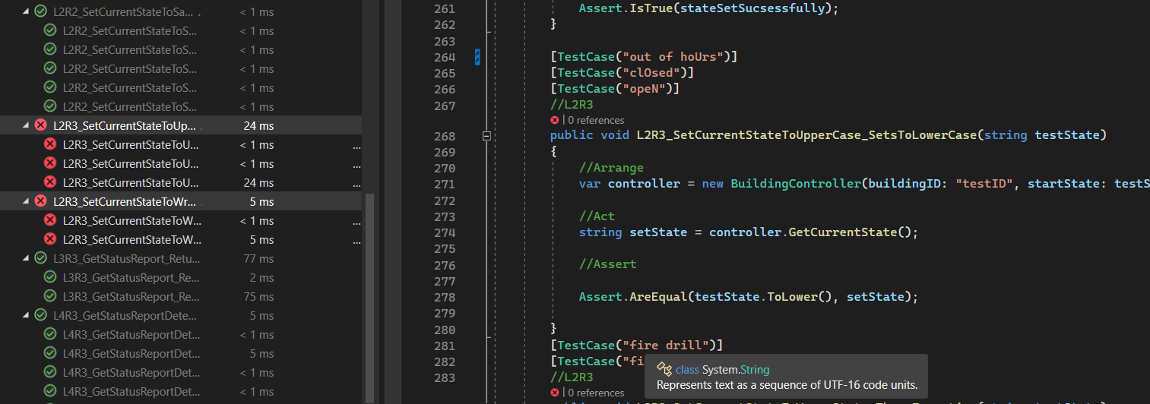

## 3.2 GREEN state

To go to the green state, the necessary code was added to the class.

Before:

**public BuildingController(string buildingID, string startState)**

**{**

**}**

After:

**public BuildingController(string buildingID, string startState)**

**{**

**this.buildingID = buildingID.ToLower();**

**startState = startState.ToLower();**

**if (validStates.Contains(startState))**

**{**

**this.currentState = startState;**

**}**

**else**

**{**

**throw new ArgumentException("Argument Exception: BuildingController can only be initialised to the following states 'open', 'closed', 'out of hours'");**

**}**

**}**

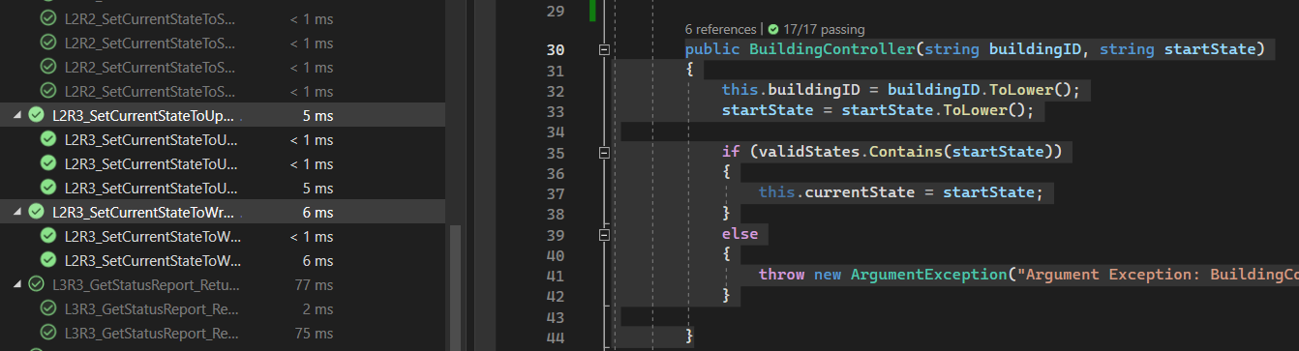

## 3.3 REFACTOR state

During refactor state nothing was done. This is due to the fact that there is nothing to be done.

# L3R3- Level 3 RED-GREEN-REFACTOR cycle

## 4.1 RED state

To fulfil this requirement, first the code for the test was created and then the functional code was created. Only the requirements part of the brief was consulted with.

**public void L3R3_GetStatusReport_ReturnsCorrectString(string testString1, string testString2, string testString3 )**

**{**

**//Arrange**

**ILightManager lightManager = Substitute.For<ILightManager>();**

**lightManager.GetStatus().Returns(testString1);**

**IDoorManager doorManager = Substitute.For<IDoorManager>();**

**doorManager.GetStatus().Returns(testString2);**

**IFireAlarmManager fireAlarmManager = Substitute.For<IFireAlarmManager>();**

**fireAlarmManager.GetStatus().Returns(testString3);**

**IWebService webService = Substitute.For<IWebService>();**

**IEmailService emailService = Substitute.For<IEmailService>();**

**var controller = new BuildingController("testID", lightManager, fireAlarmManager, doorManager, webService, emailService );**

**//Act**

**var report = controller.GetCurrentReport();**

**//Asset**

**Assert.AreEqual (testString1 + testString2 + testString3, report);**

**}**

The test is in the red state because there is no functional code for it yet.

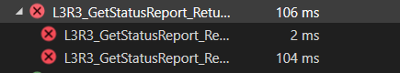

## 4.2 GREEN state

To go to the green state, the necessary code was added to the class.

Before:

**public string GetCurrentReport()**

**{**

**return "";**

**}**

After:

**public string GetCurrentReport()**

**{**

**if (doorManager != null && lightManager != null && fireAlarmManager != null && webService != null)**

**{**

**string faultyLights = lightManager.GetStatus().Contains("FAULT") ? "Lights," : "";**

**string faultyDoors = doorManager.GetStatus().Contains("FAULT") ? "Doors," : "";**

**string faultyFireAlarm = fireAlarmManager.GetStatus().Contains("FAULT") ? "FireAlarm," : "";**

**webService.LogEngineerRequired(faultyLights + faultyDoors + faultyFireAlarm);**

**return lightManager.GetStatus() + doorManager.GetStatus() + fireAlarmManager.GetStatus();**

**}**

**return "";**

**}**

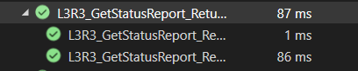

## 4.3 REFACTOR state

During refactor stage a check for null for dependencies was added.

Before :

**public string GetCurrentReport()**

**{**

**return lightManager.GetStatus() + doorManager.GetStatus() + fireAlarmManager.GetStatus();**

**}**

After:

**public string GetCurrentReport()**

**{**

**if (doorManager != null && lightManager != null && fireAlarmManager != null && webService != null)**

**{**

**string faultyLights = lightManager.GetStatus().Contains("FAULT") ? "Lights," : "";**

**string faultyDoors = doorManager.GetStatus().Contains("FAULT") ? "Doors," : "";**

**string faultyFireAlarm = fireAlarmManager.GetStatus().Contains("FAULT") ? "FireAlarm," : "";**

**webService.LogEngineerRequired(faultyLights + faultyDoors + faultyFireAlarm);**

**return lightManager.GetStatus() + doorManager.GetStatus() + fireAlarmManager.GetStatus();**

**}**

**return "";**

**}**

# L4R1- Level 4 RED-GREEN-REFACTOR cycle

## 5.1 RED state

To fulfil this requirement, first the code for the test was created and then the functional code was created. The requirements and Class Diagram part of the brief was consulted with.

**[Test]**

**//L4R1**

**public void L4R1_SetStatusToClosed_OpenAllDoorsAndSetAllLIghtMethodsAreCalled()**

**{**

**//Arrange**

**ILightManager lightManager = Substitute.For<ILightManager>();**

**IDoorManager doorManager = Substitute.For<IDoorManager>();**

**IFireAlarmManager fireAlarmManager = Substitute.For<IFireAlarmManager>();**

**IWebService webService = Substitute.For<IWebService>();**

**IEmailService emailService = Substitute.For<IEmailService>();**

**var controller = new BuildingController("testID", lightManager, fireAlarmManager, doorManager, webService, emailService);**

**//Act**

**controller.SetCurrentState("closed");**

**//Assert**

**doorManager.Received().LockAllDoors();**

**lightManager.Received().SetAllLights(false);**

**}**

<Choose any Level 4 Requirement. State its id in the heading above (replace ‘x’). Describe how you went about to create one or more tests for your selected requirement. Which part of the assignment brief did you consult (e.g., Class Diagram, State Transition Diagram, previous requirements, etc.)? Add you test below (copy and paste) and explain why you are in the RED state. Also add a screenshot showing the Test Explorer with the failing test(s).>

## 5.2 GREEN state

<Describe what you did to go to the GREEN state. Provide (copy and paste) the code in your BuildingController.cs class **before** and **after** this change. In your Test Explorer run the test again. Add a screenshot showing the Test Explorer with the passing test(s).>

## 5.3 REFACTOR state

<Describe what you did during REFACTOR stage. Provide (copy and paste) the code in your BuildingController.cs class **before** and **after** refactoring.>

# STD – Valid States and Valid Transitions

<Provide your final code showing your implementation of the State Transition Diagram (STD). In addition to the in-line comments in your code, describe your algorithm and how you translated the STD into a test and then into code.>

# Stubs and Mocks

<Describe in your own words and giving examples from your solution, what is the purpose of stubs, what is the purpose of mocks and what their differences are. Provide screenshots to support your description.>

# Lessons Learned and Conclusion

<Describe what you have learned by working on this TDD project, and explain what you would do differently next time you have a similar task. Give specific examples of things you would change or skills and capabilities you developed by working on this project.>

<after hen you have finished adding your text in the sections above, remember to go to Table of Contents and update the entire table!>

# References

<Use Harvard Referencing style>

<https://books.google.com.cy/books?id=vLkrDwAAQBAJ&dq=test-driven+development+%2B+Test+Automation+engineer,+QA+engineer,+DevOps,+software+architect,+release+manager+&lr=&source=gbs_navlinks_s>

<https://digitalcommons.calpoly.edu/cgi/viewcontent.cgi?article=1034&context=csse_fac>

https://books.google.com.cy/books?id=76rnV5Exs50C&source=gbs_navlinks_s